The amazing Seed Zeng; The jackass Chris ogle; The undetectable Mengna Lin

2.

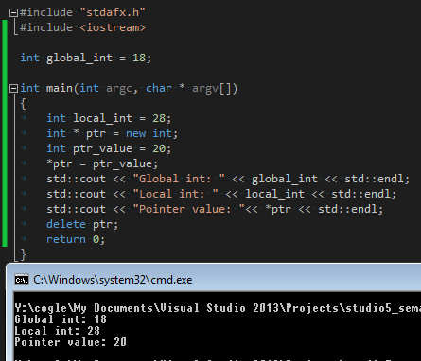

3.

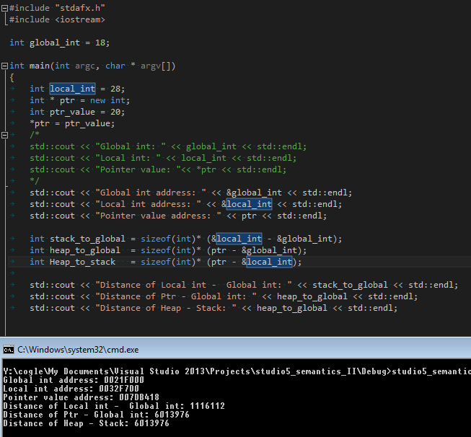

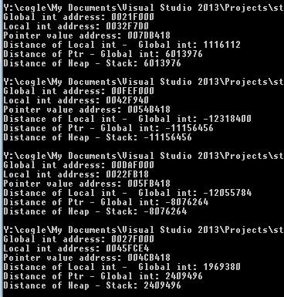

So the distances (even the signs) are changing every single time. This suggests that the addresses of all the pointers depend upon the architecture of the computer and how the memory is allocated when running the problem

4.

(a)

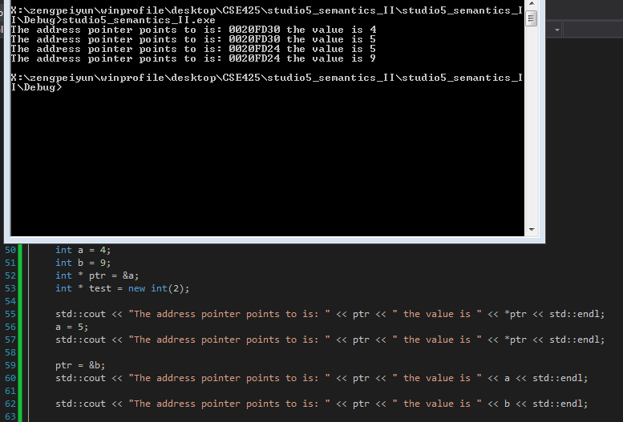

(1)

If you change where the ptr is pointing to, the &ptr (address of the pointer itself) will not be changing but ptr (the adress it contains/points to) changes

(2)

Then both &ptr and ptr won’t be changing but \* ptr changes (the value at the address where pointer points to)

(3)

both changes

5. Ask Chris about what means